**Assignment No-3**

*Roll No:- 223203*

*Name:- Sohel Mehbub Mulani.*

1:Write a program to create student class with data members rollno, marks1,mark2,mark3.

Accept data (acceptInfo()) and display using display member function.

Also display total,percentage and grade.

**public** **class** StudentExam {

**private** String name;

**private** **int** rollNo;

**private** **float** sum=0;

**private** String grade;

**float** m1,m2,m3,m4;

**public** **void** assignExam(String nm,**int** rNo, **float** m1,**float** m2,**float** m3,**float** m4){

**this**.name=nm;

**this**.rollNo=rNo;

**this**.m1=m1;

**this**.m2=m2;

**this**.m3=m3;

**this**.m4=m4;

sum=m1+m2+m3+m4;

}

**public** String grade() {

**float** per;

per=sum/4.0f;

**if** (per >= 75)

grade = "A+";

**else** **if** (per > 75 && per <= 60)

grade = "A";

**else** **if** (per < 60 && per >= 50)

grade = "B";

**else**

grade = "C";

**return** grade;

}

**public** **void** resultExam() {

String gradenew=grade();

System.***out***.println("Stu Name: "+name+". RollNO: "+rollNo+". Total Mark"+sum+". Grade"+gradenew);

}

}

**import** java.util.Scanner;

**public** **class** TestStudentExam {

**public** **static** **void** main(String[] args) {

// **TODO** Auto-generated method stub

Scanner sc = **new** Scanner(System.***in***);{

System.***out***.println("How many student are in class");

**int** i = sc.nextInt();

StudentExam[] myExam = **new** StudentExam[i];

**for** (i = 0; i < myExam.length; i++) {

myExam[i] = **new** StudentExam();// v imp line

System.***out***.println("Enter student name-RollNo-m1-m2-m3- m4");

myExam[i].assignExam(sc.next(), sc.nextInt(), sc.nextFloat(), sc.nextFloat(), sc.nextFloat(),

sc.nextFloat()); }

**for** (i = 0; i < myExam.length; i++) {

myExam[i].resultExam();

}

sc.close();}

}

}

*OutPut:-*

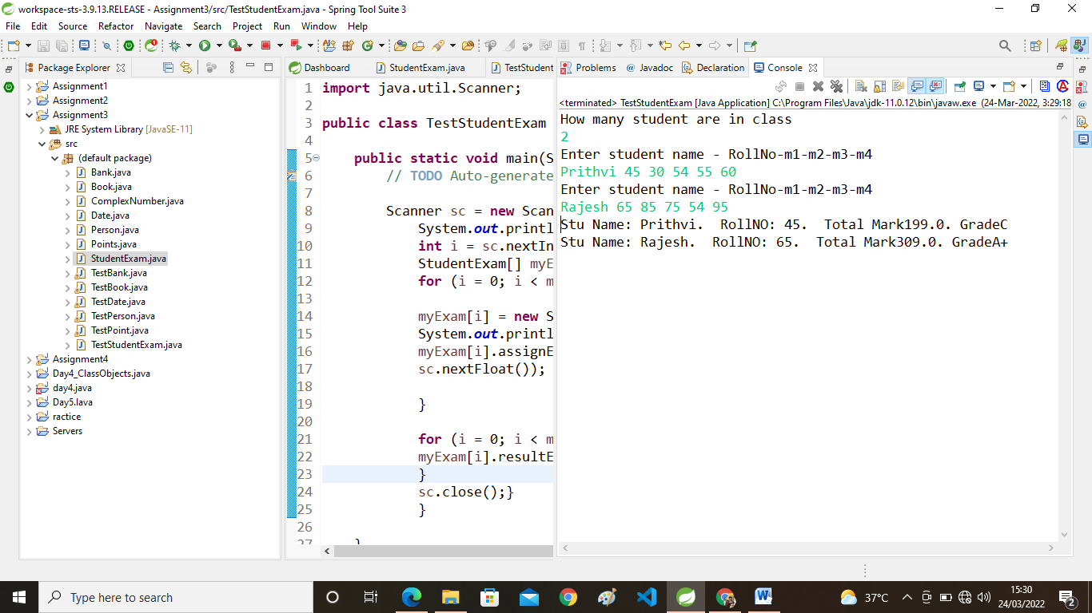

2. Create a class Person with data members as name, age, city. Write getters and setters for all the data

members. Also add the display function. Create Default and Parameterized constructors. Create the

object of this class in main method and invoke all the methods in that class.

**public** **class** Person {

**private** String name;

**private** **int** age;

**private** String city;

**public** **void** assignPerson(String name,**int** age,String city) //para

{

**this**.name=name;

**this**.age=age;

**this**.city=city;

}

**public** **void** displayPerson()

{

System.***out***.println("Name:"+name+"Age: "+age+"City: "+city);

}

**public** String getName() {

**return** name;

}

**public** **void** setName(String name) {

**this**.name = name;

}

**public** **int** getAge() {

**return** age;

}

**public** **void** setAge(**int** age) {

**this**.age = age;

}

**public** String getCity() {

**return** city;

}

**public** **void** setCity(String city) {

**this**.city = city;

}

}

**import** java.util.Scanner;

**public** **class** TestPerson {

**public** **static** **void** main(String[] args) {

// **TODO** Auto-generated method stub

Person p=**new** Person();

Scanner sc=**new** Scanner(System.***in***);

System.***out***.println("Enter Person Details:");

p.assignPerson(sc.next(), sc.nextInt(), sc.next());

p.displayPerson();

System.***out***.println("Enter New Age");

p.setAge(sc.nextInt());

System.***out***.println("After Updated Date");

p.displayPerson();

}

}

*OutPut:-*

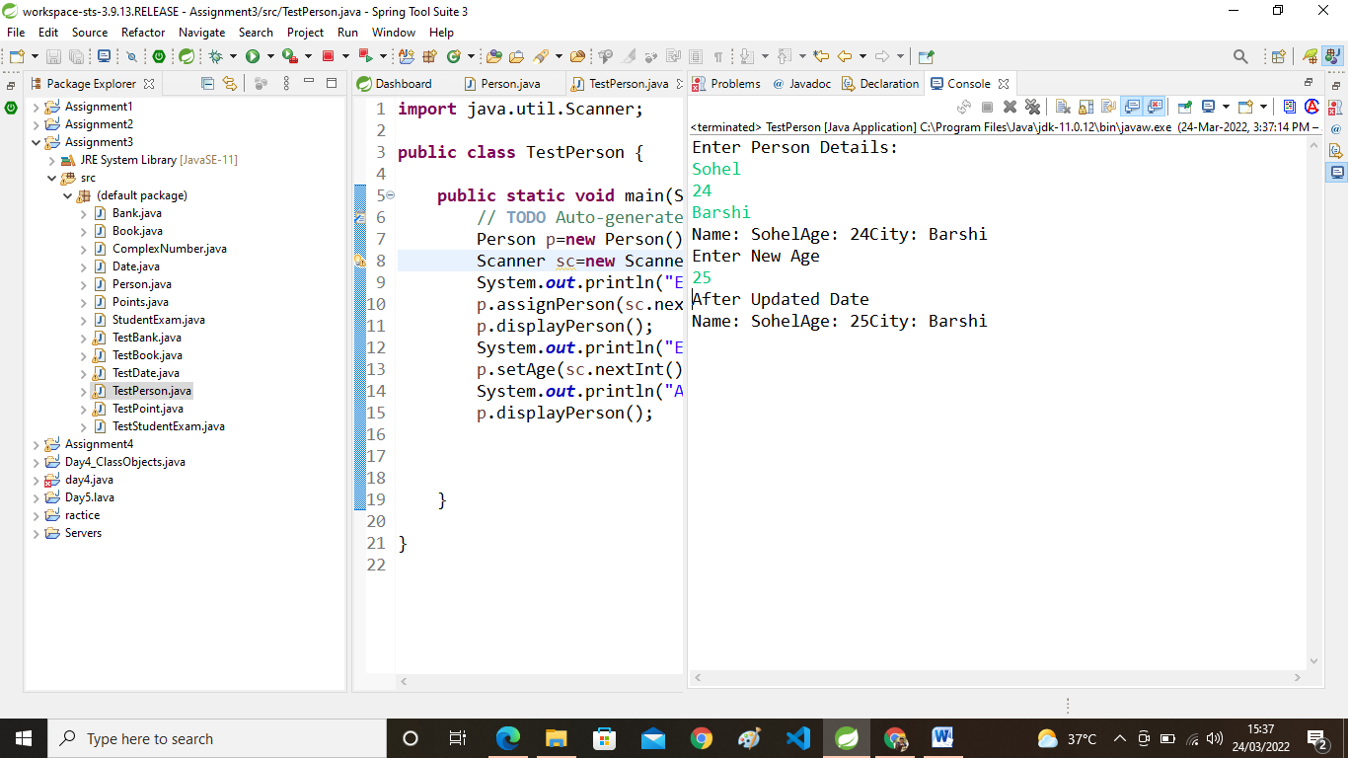

3. Create a class Date with data members as dd, mm, yy. Write getters and setters for all the data members. Also add the display function. Create Default and Parameterized constructors. Create the

object of this class in main method and invoke all the methods in that class.

**public** **class** Date {

**private** **int** dd;

**private** **int** mm;

**private** **int** yy;

**public** **void** assignDate(**int** dd,**int** mm, **int** yy)

{

**this**.dd=dd;

**this**.mm=mm;

**this**.yy=yy;

}

**public** **void** displayDate()

{

System.***out***.println(dd+"/" +mm+ "/" +yy);

}

**public** **int** getDd() {

**return** dd;

}

**public** **void** setDd(**int** dd) {

**this**.dd = dd;

}

**public** **int** getMm() {

**return** mm;

}

**public** **void** setMm(**int** mm) {

**this**.mm = mm;

}

**public** **int** getYy() {

**return** yy;

}

**public** **void** setYy(**int** yy) {

**this**.yy = yy;

}

}

**import** java.util.Scanner;

**public** **class** TestDate {

**public** **static** **void** main(String[] args) {

// **TODO** Auto-generated method stub

Date d=**new** Date();

Scanner sc=**new** Scanner(System.***in***);

System.***out***.println("Enter Date:");

d.assignDate(sc.nextInt(), sc.nextInt(), sc.nextInt());

System.***out***.println("Date:");

d.displayDate();

}

}

**OutPut:-**

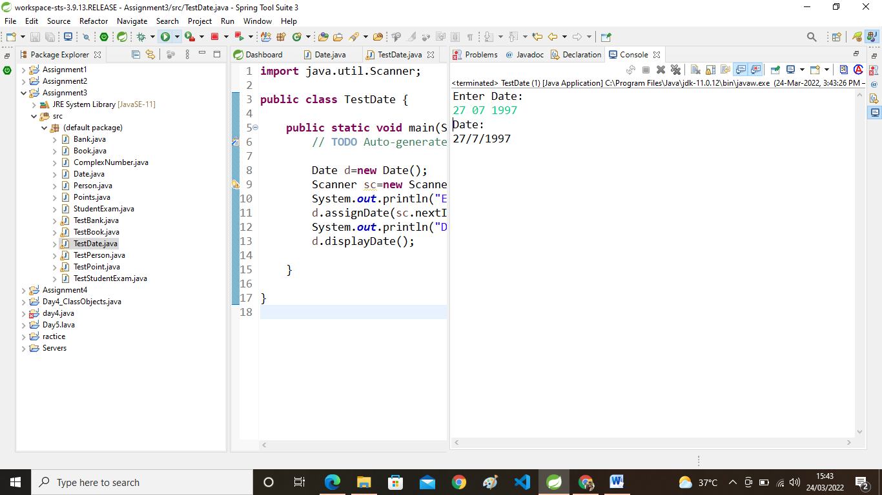

4. Create a class Book with data members as bname,id,author,price. Write getters and setters for all the

data members. Also add the display function. Create Default and Parameterized constructors. Create

the object of this class in main method and invoke all the methods in that class.

**public** **class** Book {

**private** String bname;

**private** **int** bid;

**private** String auther;

**private** **int** price;

**public** **void** assignBook(String bname,**int** bid,String auther,**int** price)

{

**this**.bname=bname;

**this**.bid=bid;

**this**.auther=auther;

**this**.price=price;

}

**public** **void** displayBook()

{

System.***out***.println(bname+ " ");

System.***out***.println(bid+ " ");

System.***out***.println(auther+ " ");

System.***out***.println(price+ " ");

}

**public** String getBname() {

**return** bname;

}

**public** **void** setBname(String bname) {

**this**.bname = bname;

}

**public** **int** getBid() {

**return** bid;

}

**public** **void** setBid(**int** bid) {

**this**.bid = bid;

}

**public** String getAuther() {

**return** auther;

}

**public** **void** setAuther(String auther) {

**this**.auther = auther;

}

**public** **int** getPrice() {

**return** price;

}

**public** **void** setPrice(**int** price) {

**this**.price = price;

}

}

**import** java.util.Scanner;

**public** **class** TestBook {

**public** **static** **void** main(String[] args) {

// **TODO** Auto-generated method stub

Book b=**new** Book();

Scanner sc=**new** Scanner(System.***in***);

System.***out***.println("Enter Book Name:");

b.assignBook(sc.nextLine(), sc.nextInt(), sc.next(), sc.nextInt());

System.***out***.println("Book Detail:");

b.displayBook();

}

}

*OutPut:-*

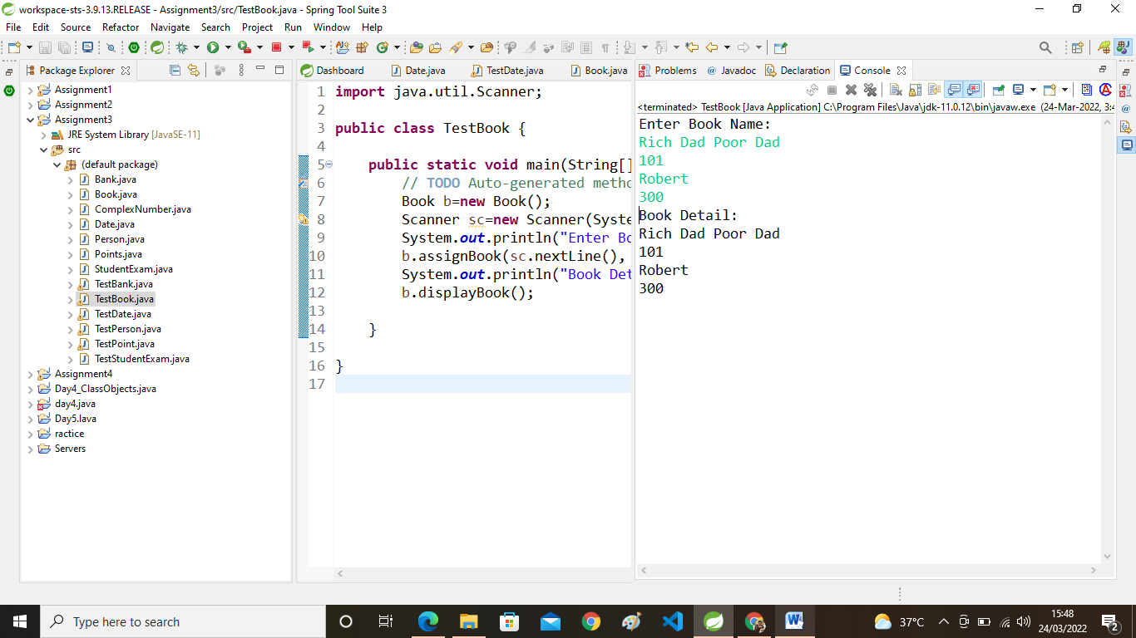

5. Create a class Point with data members as x,y. Create Default and Parameterized constructors. Write

getters and setters for all the data members. Also add the display function. Create the object of this

class in main method and invoke all the methods in that class.

**public** **class** Points {

**private** **int** x;

**private** **int** y;

**public** **void** assignPoint(**int** x,**int** y)

{

**this**.x=x;

**this**.y=y;

}

**public** **void** displayPoint()

{

System.***out***.println(x+" "+y);

}

**public** **int** getX() {

**return** x;

}

**public** **void** setX(**int** x) {

**this**.x = x;

}

**public** **int** getY() {

**return** y;

}

**public** **void** setY(**int** y) {

**this**.y = y;

}

}

**import** java.util.Scanner;

**public** **class** TestPoint {

**public** **static** **void** main(String[] args) {

// **TODO** Auto-generated method stub

Points p=**new** Points();

Scanner sc=**new** Scanner(System.***in***);

System.***out***.println("Enter Points");

p.assignPoint(sc.nextInt(),sc.nextInt());

System.***out***.println("Points Are");

p.displayPoint();

}

}

*OutPut:-*

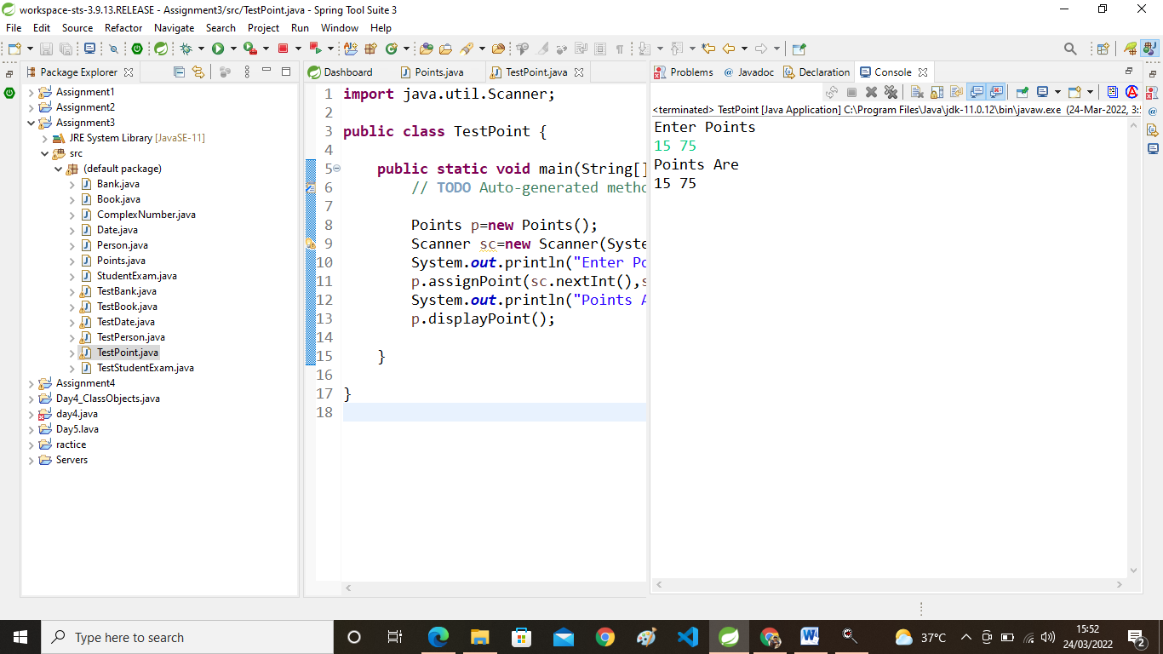

6:create BankAccount aaplication for operations like withdraw ,deposite and moneyTransfer.

Create menu drive program for bank operations.

**public** **class** Bank {

**private** **int** accountno;

**private** String holdername;

**private** **double** balance;

**public** **void** assignBank(**int** accountno,String holdername,**double** balance)

{

**this**.accountno=accountno;

**this**.holdername=holdername;

**this**.balance=balance;

}

**public** **void** display()

{

System.***out***.println(accountno+"Account no:");

System.***out***.println(holdername+"Holder Name:");

System.***out***.println(balance+"Balance:");

}

**public** **int** getAccountno() {

**return** accountno;

}

**public** **void** setAccountno(**int** b) {

**this**.accountno = b;

}

**public** String getHoldername() {

**return** holdername;

}

**public** **void** setHoldername(String holdername) {

**this**.holdername = holdername;

}

**public** **double** getBalance() {

**return** balance;

}

**public** **void** setBalance(**int** balance) {

**this**.balance = balance;

}

**public** **void** deposite(**int** amm)

{

**this**.balance=balance+amm;

}

**public** **void** withdeaw(**int** amm)

{

**this**.balance=balance-amm;

}

}

**import** java.util.Scanner;

**public** **class** TestBank {

**public** **static** **void** main(String[] args) {

// **TODO** Auto-generated method stub

Scanner sc=**new** Scanner(System.***in***);

Bank[] arr=**new** Bank[100];

**int** i = 0,index=0;

**boolean** flag=**true**;

**while**(flag==**true**)

{

System.***out***.println("1:Create Account 2:Display Statement 3:For Deposite Money");

System.***out***.println("4:For Withdraw Money 5:For Change Name 6:Exit");

System.***out***.println("Enter Choice:");

**int** choice =sc.nextInt();

**switch**(choice)

{

**case** 1:

System.***out***.println("Enter Account Details : accno,accname,balance");

arr[index]=**new** Bank();

arr[index].assignBank(sc.nextInt(), sc.next(), sc.nextDouble());

index++;

**break**;

**case** 2:

System.***out***.println("Account statment is ");

**for**(i=0;i<index;i++)

{

arr[i].display();

System.***out***.println("----------------");

}**break**;

**case** 3:

System.***out***.println("---Enter Account no. in Which You want Deposite---");

**int** ac1 = sc.nextInt();

**for** (**int** i1=0;i1<index;i1++);

{

**if** (arr[i].getAccountno()==ac1)

{

System.***out***.println("---Enter How Much Deposite---");

arr[i].deposite(sc.nextInt());

System.***out***.println("---After Deposite---");

arr[i].display();

}

}**break**;

**case** 4:

System.***out***.println("---Enter Account no. in Which You want Withdraw---");

**int** act2=sc.nextInt();

**for** (**int** i1=0;i1<index;i1++)

{

**if** (arr[i1].getAccountno()==act2)

{

System.***out***.println("---How Much Withdraw---");

arr[i1].withdeaw(sc.nextInt());

System.***out***.println("---After Withdraw---");

arr[i1].display();

}

}

**break**;

**case** 5:

System.***out***.println("Enter Acc.no of Which You Want to Name");

**int** ac=sc.nextInt();

**for** (**int** i1=0;i1<index;i1++)

{

**if**(arr[i].getAccountno()==ac)

{

System.***out***.println("---After New Name---");

arr[i].setHolderna me(sc.next());

System.***out***.println("---Updated Name is---");

arr[i].display();

}

}**break**;

**case** 6:

flag=**false**;

System.***out***.println("Thank you..!!!!!");

}

}

}

}

*OutPut:-*

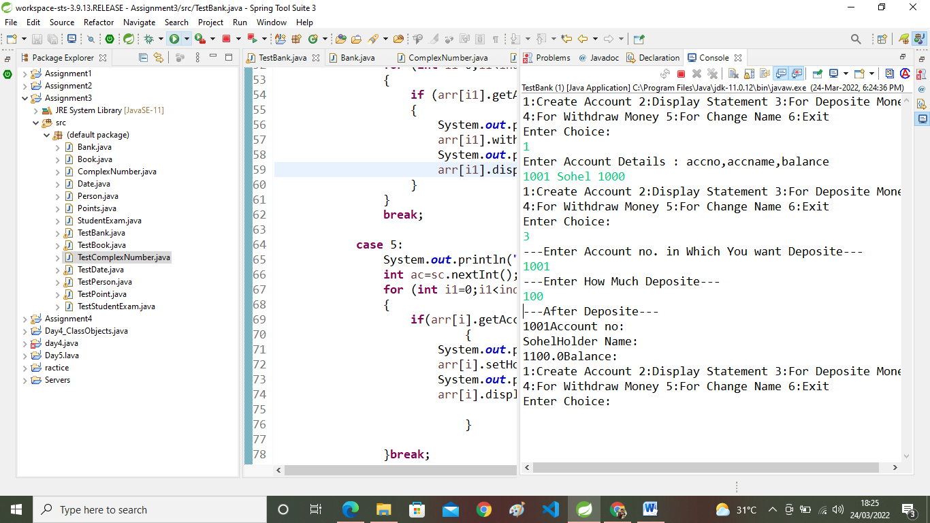

7. Create a class ComplexNumber with data members real, imaginary. Create Default and Parameterized constructors. Write getters and setters for all the data members. Also add the display function. Create the object of this class in main method and invoke all the methods in that class.

6:create BankAccount aaplication for operations like withdraw ,deposite and moneyTransfer.

Create menu drive program for bank operations.

**public** **class** ComplexNumber {

**private** **int** Real,Imaginary;

**public** ComplexNumber( )

{

Real = 78;

Imaginary = 33;

}

**public** ComplexNumber( **int** Real , **int** Imaginary)

{

**this**.Real = Real;

**this**.Imaginary = Imaginary;

}

**public** **void** displayComplexNumber( )

{

System.***out***.println("Show Complex Number - ");

System.***out***.println("Real = "+Real);

System.***out***.println("Imaginary = "+Imaginary);

}

**public** **void** setImaginary(**int** Imaginary )

{

**this**.Imaginary = Imaginary;

}

**public** **int** getImaginary( )

{

**return** **this**.Imaginary;

}

**public** **void** setReal(**int** Real )

{

**this**.Real = Real;

}

**public** **int** getReal( )

{

**return** **this**.Real;

}

}

**import** java.util.Scanner;

**public** **class** TestComplexNumber {

**public** **static** **void** main(String[] args) {

// **TODO** Auto-generated method stub

ComplexNumber cn;

cn = **new** ComplexNumber ( );

System.***out***.println("---Default Constructor----");

cn.displayComplexNumber ( );

System.***out***.println("-----------------------");

System.***out***.println("---Parametersized Constructor---");

Scanner sc;

sc = **new** Scanner(System.***in***);

**int** real , imaginary;

System.***out***.print("Enter Real - ");

real = sc.nextInt( );

System.***out***.print("Enter Imaginary - ");

imaginary = sc.nextInt( );

cn = **new** ComplexNumber ( real , imaginary);

cn.displayComplexNumber ( );

System.***out***.println("-----------------------");

System.***out***.print("Enter the correct imaginary Number - ");

imaginary = sc.nextInt ( );

cn.setImaginary(imaginary);

cn.displayComplexNumber ( );

System.***out***.println("---------------------------");

System.***out***.println("Get the Imaginary Number - ");

imaginary = cn.getImaginary ( );

System.***out***.println("Imaginary Number - "+imaginary);

System.***out***.println("-----------------------");

System.***out***.print("Enter the correct Real Number - ");

real = sc.nextInt ( );

cn.setReal(real);

cn.displayComplexNumber ( );

System.***out***.println("-------------------------");

System.***out***.println("Get the Real Number - ");

real = cn.getReal ( );

System.***out***.println("Real Number - "+real);

System.***out***.println("--------------------------");

sc.close( );

}

}

***OutPut:-***

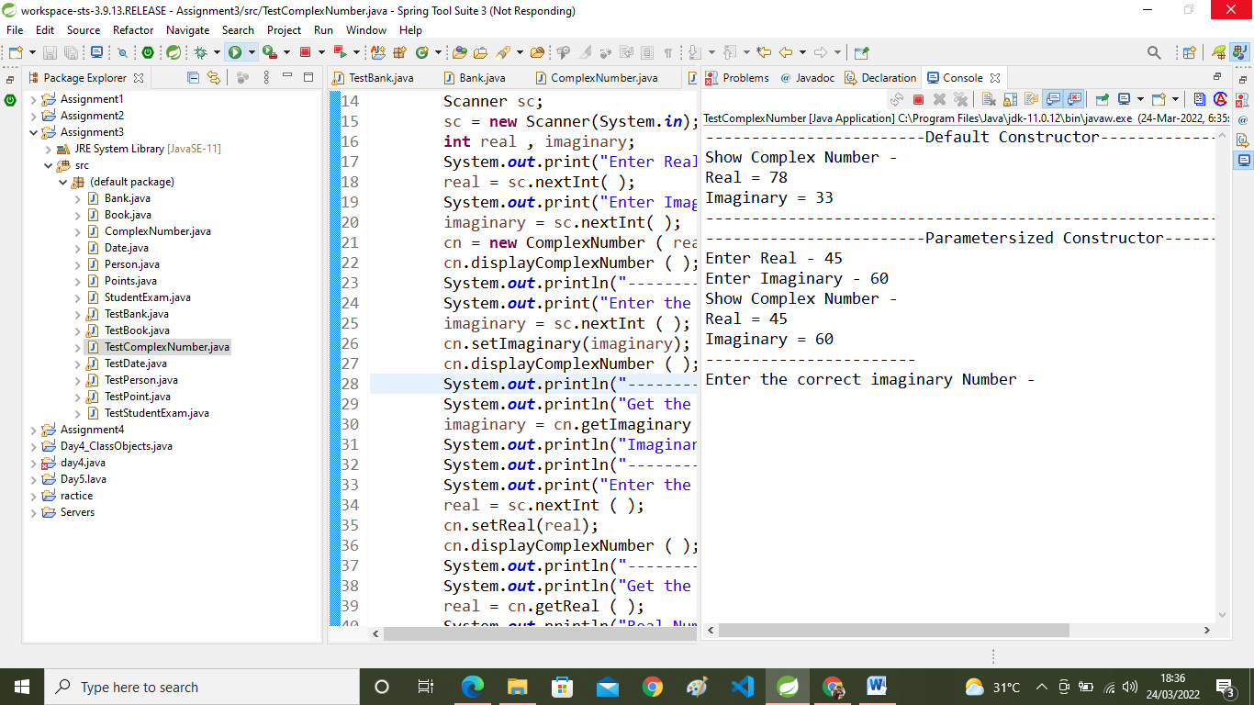

8:Create array of BankAccount class and store 5 objects....create menu driven application for same.....ex. show all account names ,balance,email...

**public** **class** BankAccount {

**private** **int** actno;

**private** String name;

**private** **double** balance;

**private** **double** creditLimit;

**public** BankAccount()

{

System.***out***.println("----default----");

**this**.actno=101;

**this**.name="Sohel";

**this**.balance=10000;

**this**.creditLimit=40000;

}

**public** BankAccount(**int** actno,String name,**double** balance,**double** creditLimit)

{

System.***out***.println("----parameter constr-----");

**this**.actno=actno;

**this**.name=name;

**this**.balance=balance;

**this**.creditLimit=creditLimit;

}

**public** **void** display()

{

System.***out***.println(actno+" "+name+" "+balance+" "+creditLimit);

System.***out***.println("-----------------------");

}

**public** **void** deposite(**double** amount)

{

**this**.balance=**this**.balance+amount;

System.***out***.println("After Deposite Balance ="+balance);

}

**public** String getName()

{

**return** **this**.name;

}

**public** **int** getActno()

{

**return** **this**.actno;

}

**public** **double** getCreditLimit()

{

**return** **this**.creditLimit;

}

**public** **double** getBalance()

{

**return** **this**.balance;

}

**public** **void** setName(String name)

{

**this**.name=name;

}

**public** **void** setCreditLimit(**double** limit)

{

**this**.creditLimit=limit;

}

**public** **void** moneyTranser(**double** amount ,BankAccount reciver)

{

**this**.balance=**this**.balance-amount;

reciver.balance=reciver.balance+amount;

System.***out***.println("Money Sent from "+**this**.actno +" to "+reciver.actno);

}

}

{

**this**.name=name;

}

**public** **void** setCreditLimit(**double** limit)

{

**this**.creditLimit=limit;

}

**public** **void** moneyTranser(**double** amount ,BankAccount reciver)

{

**this**.balance=**this**.balance-amount;

reciver.balance=reciver.balance+amount;

System.***out***.println("Money Sent from "+**this**.actno +" to "+reciver.actno);

}

}

***OutPut:-***